This booklet can help you get the most out of your mediation session by helping you:
- Be prepared.
- Get organised.
- Plan what you want to say and how to say it.
- Know what to expect on the day.
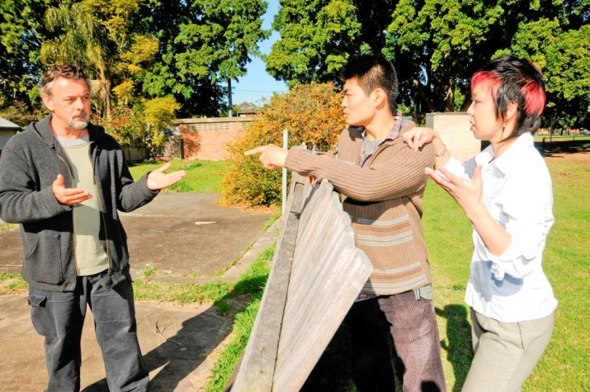
This booklet contains information and activities to prepare you for mediation. There are spaces for your notes.
The booklet is:
- Confidential – it is not shown or given to the mediators or the others involved in the dispute.
- A reminder of what to say – not a replacement for talking to the other person at mediation.
- Not notepaper – any notes taken at the session may be destroyed by the mediator. If you want to keep the booklet after the mediation, you can write on it before but not during the session.

Remember
The aim of mediation is to reach an agreement everyone can live with.
Even though you and the other person cannot agree at the moment, mediation can help you discover new options and communicate better with each other.
The mediators can help you communicate and develop solutions, but won’t take sides or make a decision for you.

How to contact us
If you would like more information about preparing for mediation, please contact us on:
Freecall: 1800 990 777 | Fax: (02) 8688 9616 Email: cjc-info@justice.nsw.gov.au
If you are deaf or have a hearing impairment or speech impairment, contact us through the National Relay Service on 1800 555 677 and ask for 1800 990 777.
© State of New South Wales through the Department of Communities and Justice 2019. You may freely deal with this work for any purpose, other than for profit.
This document was prepared in February 2012 by the department for general information purposes only.

Preparation tips
- Complete the activities in this booklet – this will help you prepare what you want to say and how to say it.
- Read the flowchart about what to expect on the day at the back of this booklet so that you know what will happen at the mediation.
- Stay open-minded about how the dispute may be resolved. New ideas that are worth considering might emerge during the mediation session.
- Be flexible and give yourself plenty of room to negotiate. Don’t back yourself into a corner by issuing ultimatums – new information may come to light that will make you want to change your mind.
- Be willing to give and take – you will be expecting the other person to compromise to meet your needs, be prepared to do the same.
- Stay calm and focussed. Show respect for the other party and the mediator when you communicate.
- Stay positive – your attitude will help others stay positive too.

Communication tips
- Listen carefully to what the mediators and the other person says.
- Try to speak clearly and calmly.
- Take turns when speaking, don’t interrupt the other person or speak over them.
- Write down the things you would like to say so you don’t forget them when it is your turn to speak.
- Make sure you understand exactly what others are saying and ask questions if you don’t understand something.
- Remember the other person might be feeling emotional and how you speak to them might affect how they feel and how willing they are to compromise with you.

Preparing what to say at the start of the mediation
Mediation is a chance for you to talk about what you think the dispute issues are and to hear what the other person has to say. The mediators will help the discussion, but it is your role to speak to the other person about the issues in an open, honest and respectful way. After the mediators introduce everyone and explain what will happen, each person will be asked to speak for a few minutes about what brought them to mediation.
In the space below:
- Make a list of what the dispute is about and your main concerns.
- Keep the points short and to the point.
- Try not to use negative or blaming words that might make the other person angry or defensive. For example, you could say, ‘I am upset about the leaves in my garden from the tree because they make a mess’, instead of, ‘You have ruined my garden with your leaves’.
- Be specific - give enough detail for the other person to know exactly what you are talking about.
Sample response: I would like to talk about the branch from the tree that hangs over the south side of my backyard. The fallen leaves make a mess. It blocks the sunlight. The clothesline is shaded. The plants won’t grow. It is also causing the fence to fall down. I am having difficulty speaking to my neighbour about the fence or tree. I would like to use this mediation session to try to solve this problem and improve my relationship with my neighbour.
I would like to talk about:

Listing the issues in your dispute
It’s important that you organise your thoughts about the dispute. Complete the table to help you.
Issue | What I want | Why I want it | Why is it so important?
Eg. Overhanging tree. | The tree removed. | Leaves make mess, too much shade. | My kids need a tidy yard to play in. I need to dry the washing.
Eg. My neighbour refusing to speak to me about the tree. | For my neighbour to listen to my concerns. | So that my neighbour understands my concerns and shows me some respect. | Not being listened to or having my needs respected upsets me.

Considering the other person’s point of view
Thinking about what the other person wants and why it is important to them will help you communicate and negotiate with them. Complete the table to help you try to imagine the dispute from the other person’s point of view.
Issue | What the other person wants | Why the other person wants it | Why the other person thinks it’s important
Eg. Overhanging tree. | The tree to stay. | The tree is attractive, it gives privacy. | I like trees and privacy. I have a right to my tree.
Eg. My neighbour yelling at me about the tree. | To stop the yelling and talk calmly if necessary. | I don’t want to end up in a heated discussion or fight. | I find conflict very stressful and try to avoid it by staying away.

Coming up with options to resolve the dispute
Now try to think of different options to discuss with the other person. Consider what is important to each of you and write down some options that you think everyone can live with.
Sample response: Trim the tree regularly to let in some sunshine and reduce leaf litter, but keep privacy and the beauty of the tree.

Will you need to deal with the other person in the future?
(If you will not have to deal with the other person in the future, you can skip this activity.)
If you will have to see or spend time with the other person in the future (for example because they are your neighbour, family member or workmate) is it important that you and the other person can get along and talk to each other in the future? If so, write down ideas for how your communication and interaction could be improved.
For example, your mediation agreement could include ground rules like agreeing to write letters about any problems or have a monthly conversation about how things are going.

What if you can’t agree?
Think about the best and the worst possible outcomes if you can’t reach an agreement. How likely is each of these outcomes? Write down what may happen if you can’t resolve the issue at mediation:
For example, you may have to put up with the situation, pay to fix it yourself, hire a lawyer, go to court, or move away.

Do you need any information?
You may need some information to help you:
- Know what you can and can’t do about your situation.
- Work out whether some options are possible.
- Find out what you may need to ask the other person at the mediation session.
This information could be from your local council, your body corporate, your real estate agent, a government department or an expert (eg tree lopper, car mechanic, fence builder, accountant).
If your dispute involves potential legal rights and responsibilities, you may want to get legal information or advice before your session. You may wish to understand your legal options even though mediation can include non-legal issues and you are free to make an agreement that is different to your strict legal rights.
Sample response: Local councils have tree preservation orders that may apply to my type of tree. LawAssist has information on its website about fences and my rights and responsibilities.
Write a list of any information you need:

What documents should you bring?
Documents that may be relevant, depending on the particular situation, are:
- Photographs.
- Quotes.
- Invoices.
- Notes.
- Plans.
- Formal documents, eg noise complaints, letters, contracts.
You can use the documents to explain your point of view to the other person. Note that the mediators will not look at these documents. They do not make any judgements or decisions for you. They help you and the other person to communicate.
Make a list of the things you want to bring to the mediation:

What to expect on the day
CJC mediation generally follows these steps:
Introductions

Mediators explain the process and 'ground rules' for the mediation.

Each person has a chance to give a short description of their concerns. Activity 1 will help you prepare for this step.

Mediators summarise what each person has said and everyone agrees on a list of issues to discuss.

Mediators help everyone explore the issues. This means communicating in detail about what your concerns are and why you feel they are important. Activities 2 & 3 will help you here.

Mediators see each person in a confidential private session while the other person has time to think about their options. Activity 4 will help you here.

Mediators bring everyone back together and help them to come up with ideas about how to resolve the dispute. Activities 5, 6 and 7 may help here.

If everyone agrees on some or all of the issues, the mediators can write an agreement and give a copy to each person as a record of what was decided. Agreements are not normally legally binding, but it may be possible to have them made legally binding if everyone agrees.

If an agreement is not reached, but everyone agrees further mediation may help, another session can be arranged.

The mediators will provide you with Feedback Forms and a self-addressed envelope. You can complete the form at the end of the mediation, put it in the sealed envelope and hand it to a mediator or you can post it to us later. You can also provide feedback to CJC by contacting us.

Remember
- Mediators do not give advice or take sides.
- Mediation sessions are confidential – what is said at the session cannot usually be used as evidence in court unless you, the other person and the mediators agree (note there are some limited exceptions, for example where information relates to the safety of a person).
- We allow plenty of time for the mediation, usually between two to four hours – please make sure you have made arrangements for car parking, child minding, work, etc.
- You can ask for a break at any time during the mediation.
- CJC cannot give you legal advice or information. If you think you may need some legal information before your mediation, you can speak to a lawyer or call LawAccess on 1300 888 529 for free legal information and referrals.
- You can call CJC on freecall 1800 990 777 if you have any questions.

Congratulations!
Now that you have completed the activities in this booklet you have increased your chances of resolving your dispute.
All the best for your session!
